Impact of Climate Change
Based on the IPCC-AR6 report
By Anushthan Saxena (S20210010027)

This acts as a summary for the Working Group I ‘s contribution to the 6th Assessment Report on the physical science basis of climate change. It builds upon the findings of Working Group I for the 5th Assessment Report published in 2013 and the 2018-2019 Special Reports of the AR6 cycle, incorporating subsequent new evidence from climate science.
This acts as a high-level summary of the understanding of the current state of the climate, including how it is changing and the role of human influence, the state of knowledge about possible climate futures, information relevant to regions and sectors, and limiting human-induced climate change.
We are not concerned with much of this material, and will only focus on the impact on various climatic parameters.
Some observations relevant to us and their brief overview is listed below:

1. Surface Temperature –
Global surface temperature has increased faster since 1970 than in any other 50-year period over at least the last 2000 years.
The report provides insights upon how the surface temperature will continue to rise, new estimates of the chances of crossing the global warming level of 1.5°C in the next decades, and finds that unless there are immediate, rapid and large-scale reductions in greenhouse gas emissions, limiting warming to close to 1.5°C or even 2°C will be beyond reach.
The emissions of greenhouse gases are responsible for approximately 1.1°C of warming since 1850, and averaged over the next 20 years, the global temperature is expected to reach or even exceed 1.5°C of warming.

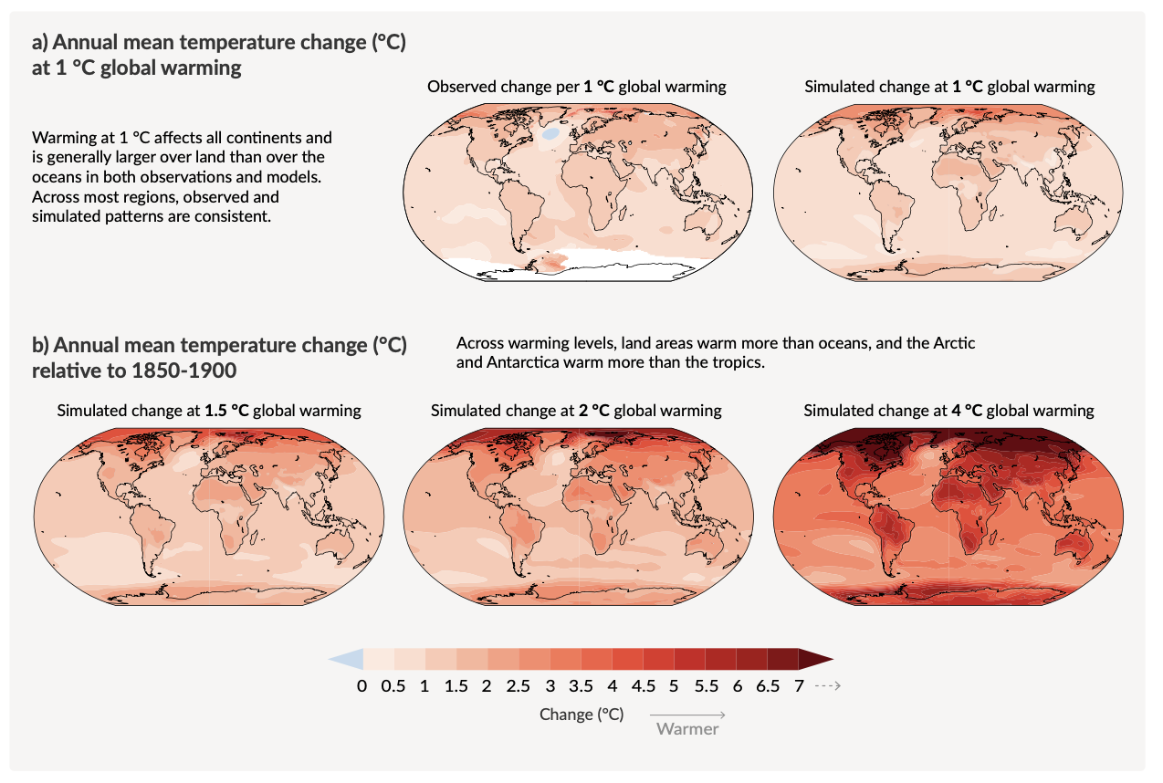

2. Precipitation –
The frequency and intensity of heavy precipitation events have increased since the 1950s over most land area. Decreases in global land monsoon precipitation from the 1950s to the 1980s are partly attributed to human-caused Northern Hemisphere aerosol emissions, but increases since then have resulted from rising GHG concentrations and decadal to multi-decadal internal variability.
Globally averaged precipitation over land has likely increased since 1950, with a faster rate of increase since the 1980s. It is likely that human influence contributed to the pattern of observed precipitation changes since the mid-20th century.
It is very likely that heavy precipitation events will intensify and become more frequent in most regions with additional global warming. At the global scale, extreme daily precipitation events are projected to intensify by about 7% for each 1°C of global warming.
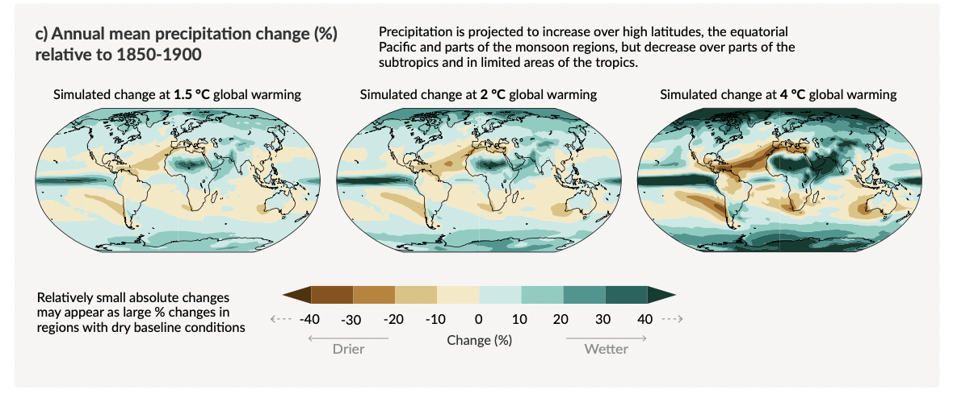

3. Ocean pH –
A long-term increase in surface open ocean pH occurred over the past 50 million years, and surface open ocean pH as low as recent decades is unusual in the last 2 million years.
AR5 assessed with high confidence that the pH of the ocean surface has decreased since preindustrial times, primarily as a result of ocean uptake of CO2. SROCC concluded that the global ocean absorbed 20–30% of total CO2 emissions since the 1980s, with virtually certain ocean surface pH decline.
It is virtually certain that surface open ocean pH has declined globally over the last 40 years by 0.003–0.026 pH per decade.

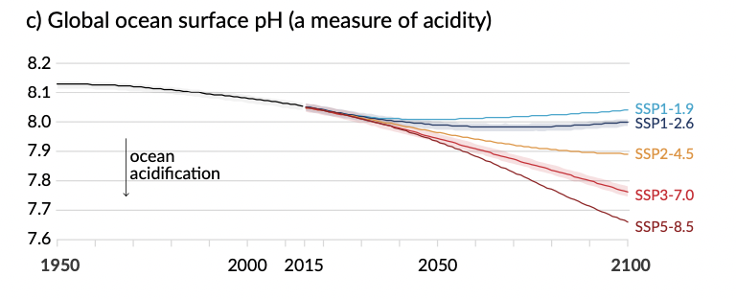

4. Sea level change –
Global mean sea level has risen faster since 1900 than over any preceding century in at least the last 3000 years. The global ocean has warmed faster over the past century than since the end of the last deglacial transition (around 11,000 years ago).
Global mean sea level increased by 0.20 [0.15 to 0.25] m between 1901 and 2018. The average rate of sea level rise was 1.3 [0.6 to 2.1] mm yr⁻¹ between 1901 and 1971, increasing to 1.9 [0.8 to 2.9] mm yr⁻¹ between 1971 and 2006, and further increasing to 3.7 [3.2 to 4.2] mm yr⁻¹ between 2006 and 2018. Human influence was very likely the main driver of these increases since at least 1971.
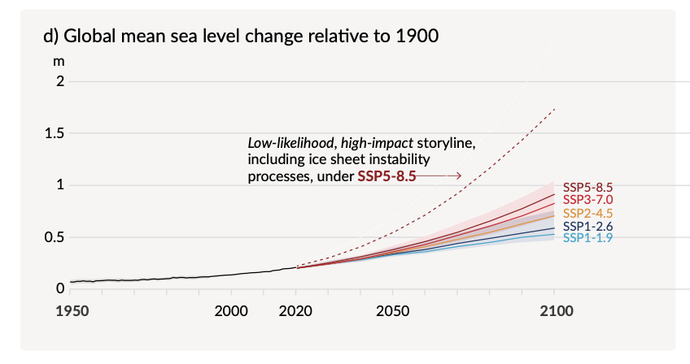

5. Arctic Sea-Ice –
In 2011–2020, annual average Arctic sea ice area reached its lowest level since at least 1850. Late summer Arctic sea ice area was smaller than at any time in at least the past 1000 years. The global nature of glacier retreat, with almost all of the world’s glaciers retreating synchronously, since the 1950s is unprecedented in at least the last 2000 years. It is very likely that human influence has contributed to the observed surface melting of the Greenland Ice Sheet over the past two decades.
The Arctic is likely to be practically sea ice free in September at least once before 2050.

